Context: This document is a Request for Information to understand the Company Shareholding/Ownership Structure and identify the Ultimate Beneficial Owners (UBO) of the Applicant business. Please complete the following sections in this form:
- Section A – Shareholding Structure
- Section B – Identified Ultimate Beneficial Owners
- Section C – UBO Declaration [ONLY if one or more UBOs identified in Section B]
- Section D – Nominated Senior Managing Official (SMO) [ONLY If no UBO identified in Section B]

This form is to be completed only by a UBO or Senior Managing official of the applicant company.
A Senior Managing Official is a person with the ability to make or participate in making decisions that affect the whole, or a substantial part of the business, and the capacity to significantly affect the financial standing of the business. Examples of acceptable SMOs include Directors, C-suite Executives, or other members of senior management.

Section A – Shareholding Structure
Please complete ONE of the following options to provide information about your company ownership structure, ensuring that the following information is covered:
- A full list of all shareholdings, including any intermediate corporate holding, down to identified natural persons
- For all intermediate holding bodies:
  - Entity Name
  - Country of incorporation/registration
  - Shareholding % of direct parent, and Shareholding % of ultimate parent (applicant business)
- For all Natural Persons
  - Full Name
  - Shareholding % of direct entity, and indirect Shareholding % of ultimate parent (applicant business)

OPTION 1: Fill shareholding details below (refer to Appendix for an example). For any row where column 5 is at or above 25% (and not an individual), ensure that the entity’s underlying owners are provided, unless the entity is publicly listed.

1. Legal Name of Owner | 2. Entity/Legal Structure Type | 3. Country of Incorporation or Residence | 4. Name of Entity Owned | 5. % Ownership | 6. Publicly Listed?
Entity or Individual Name | Entity type of [1] | Country of incorporation or residence of [1] | Entity directly owned by [1] | The % of [4] held/owned by [1] | ☐
Click [+] on the right side of the table to add rows as necessary

OPTION 2: Attach Shareholding Chart/Structure (refer to Appendix for an example structure)

☐ Alternatively, if you already have a diagram or chart of your Company Shareholding structure which provides the information above, please tick this box and attach this shareholding structure directly to the RFI request.

Section B – Identified Ultimate Beneficial Owner
Please complete the table, listing all identified UBOs (if any) of the applicant company.
A UBO is any individual who holds in aggregate (directly or indirectly), 25% or more of the applicant Company

Click [+] to add rows as necessary
UBO Full Name | Ownership of applicant Company (%) | Type(s) of ID Provided (e.g. License, Passport) | Country of Issuance for ID Provided | Confirm Copies of ID Provided | Confirm Liveness Completed OR Certified ID Provided¹
[UBO Full Name] | [%] | [ID Type] | [Country] | ☐ | ☐
[UBO Full Name] | [%] | [ID Type] | [Country] | ☐ | ☐
Click [+] on the right side of the table to add rows as necessary

☐ I confirm that all UBOs have been listed in the table above – PROCEED TO SECTION C
OR
☐ I confirm there are no individuals holding 25% or more of the above company – PROCEED TO SECTION D
Section C – UBO Declaration
Note that this section is only required if ONE OR MORE UBOs are identified in Section B Above
I, [Full First and Last Name], am the [Role Title] of [Applicant Company Name].

☐ I confirm that ALL individuals holding 25% or more of the Applicant company have been listed in Section B Above.
☐ I acknowledge that this certification is given in connection with the Anti-Money Laundering and Counter-Terrorism Financing Rules and that it is an offence under section 136 of the Anti-Money Laundering and Counter-Terrorism Financing Act 2006 (Cth) to knowingly provide false or misleading information.

Signed: [Initial/Name here to Electronically-Sign] | Date Signed: [Date Signed]
Section D – Nominated Senior Managing Official Declaration
Note that this section is only required if NO UBOs are identified in Section B Above
I, [Full First and Last Name], am the [Role Title] of [Applicant Company Name]. In my capacity as a Senior Managing Official:

☐ I confirm that there are no UBOs who hold 25% or more of the Applicant company.
☐ I confirm that I have the ability to make or participate in making decisions that affect the whole, or a substantial part of the business, and the capacity to significantly affect the financial standing of the business.
☐ I understand that I will be considered to have full sole authority to represent the company in its dealings (including the capacity to authorise others in the business to act on behalf of the business).
☐ I acknowledge that this certification is given in connection with the Anti-Money Laundering and Counter-Terrorism Financing Rules and that it is an offence under section 136 of the Anti-Money Laundering and Counter-Terrorism Financing Act 2006 (Cth) to knowingly provide false or misleading information.
☐ I have provided a copy/copies of my government-issued photo ID as required.¹

Signed: [Initial/Name here to Electronically-Sign] | Date Signed: [Date Signed]

¹ Note that if you are providing an ID other than an Australian or New Zealand Drivers License/Passport, IDs provided must either be Certified/Notarised according to the regulations of your country of residence, or alternatively, provided through Liveness by the ID holder (which can be accessed using the following link)

Appendix - Examples of shareholding structure

Please see below an example of ownership structure (with ownership >=25%).
The applicant in this scenario is ‘ABC Pty Ltd’.

Shareholding Details Table (Option 1)

1. Legal Name of Owner | 2. Entity/Legal Structure Type | 3. Country of incorporation or residence | 4. Name of Entity Owned | 5. % Ownership | 6. Publicly Listed?
Finance Holding Pty Ltd | Company | Australia | ABC Pty Ltd | 50% | □
Asia Group Pte Ltd | Company | Singapore | ABC Pty Ltd | 20% | □
Structure DC Limited | Company | New Zealand | ABC Pty Ltd | 30% | □
John Tran | Individual | Australia | Finance Holding Pty Ltd | 100% | □
Culture Fit Partners | Partnership | New Zealand | Structure DC Limited | 90% | □
Sport Z Limited | Company | New Zealand | Structure DC Limited | 10% | □
Amber Smith | Individual | New Zealand | Culture Fit Partners | 50% | □
Megan Liu | Individual | Hong Kong | Culture Fit Partners | 50% | □
Shareholding Structure (option 2)
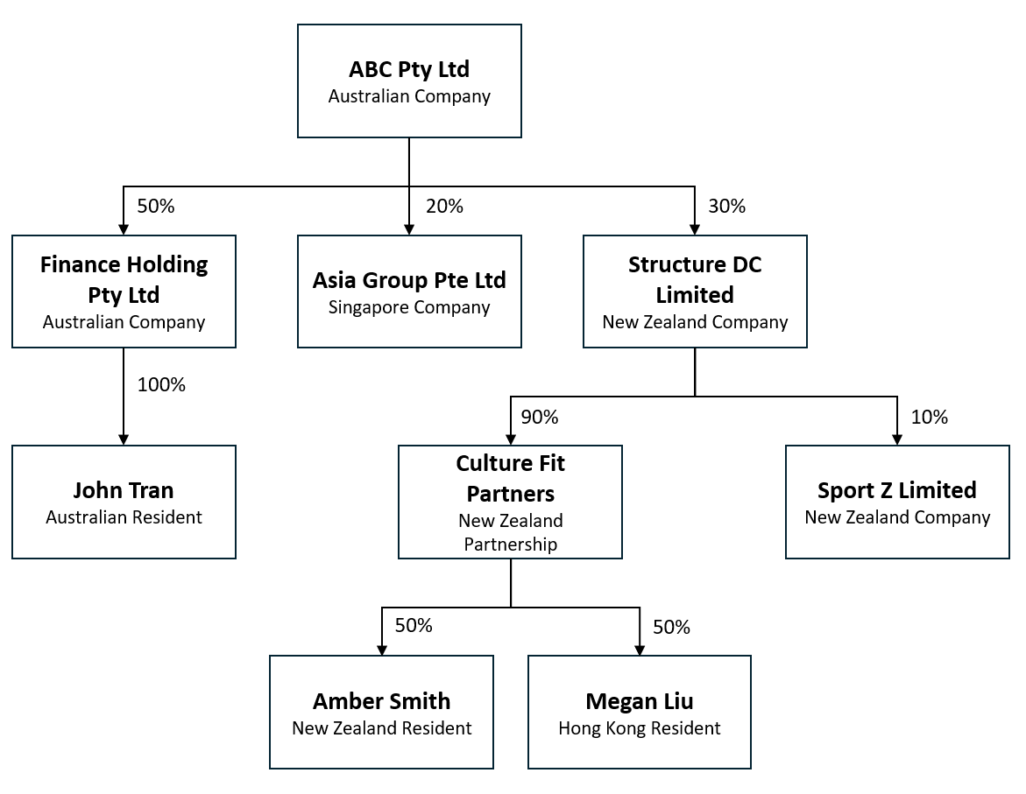

Appendix - Examples of shareholding structure

UBO Calculation methodology
Only John Tran is considered an Ultimate Beneficial Owner in this scenario (and therefore should be entered into Section B)
- John Tran: Owns 100% of Finance Holding Pty Ltd, which directly owns 50% of ABC Pty Ltd.
  - Calculation: 100% x 50% = 50% indirect ownership;
  - Result: this individual is an Ultimate Beneficial Owner (>=25%)
- Amber Smith: Owns 50% of Culture Fit Limited, which owns 90% of Structure DC Limited, which in turn owns 30% of ABC Pty Ltd.
  - Calculation: 50% x 90% x 30% = 13.5% indirect ownership;
  - Result: this individual is not an Ultimate Beneficial Owner (<25%)
- Megan Liu: Owns 50% of Culture Fit Limited, which owns 90% of Structure DC Limited, which in turn owns 30% of ABC Pty Ltd.
  - Calculation: 50% x 90% x 30% = 13.5% indirect ownership;
  - Result: this individual is not an Ultimate Beneficial Owner (<25%)

