Context: This document is a Request for Information understand the Company Shareholding/Ownership Structure and identify the Ultimate Beneficial Owners (UBO) of the Applicant business. Please complete the following sections in this form:
- Section A – Shareholding Structure
- Section B – Identified Ultimate Beneficial Owners
- Section C – Nominated Senior Managing Official (SMO) [ONLY If no UBO identified in Section B]
Section A – Shareholding Structure
Please provide a diagram of your company ownership structure below, containing the following information:
- A full list of all shareholdings, including any intermediate corporate holding, down to identified natural persons
- For all intermediate holding bodies:
  - Entity Name
  - Country of incorporation/registration
  - Shareholding % of direct parent, and Shareholding % of ultimate parent (applicant business)
- For all Natural Persons
  - Full Name
  - Shareholding % of direct entity, and indirect Shareholding % of ultimate parent (applicant business)
Illustrative example below:

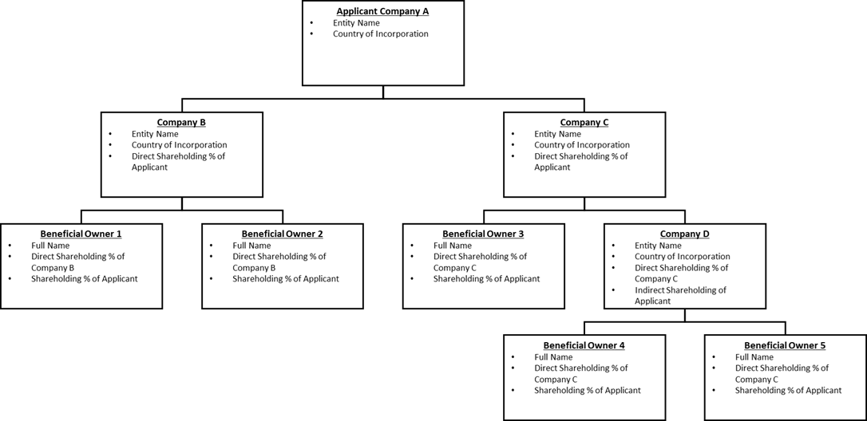

(Double click on Image above to replace with attachment)
☐ I confirm that I have inserted the Shareholding structure in the space provided above, or alternatively, separately attached/uploaded a copy of a shareholding structure as addendum to this form.

Section B – Identified Ultimate Beneficial Owner
Please complete the table, listing all identified UBOs (if any) of the applicant company.

A UBO is any individual who holds in aggregate (directly or indirectly), 25% or more of the applicant Company

UBO Full Name | Ownership of applicant Company (%) | Type(s) of ID Provided (e.g. License, Passport) | Country of Issuance for ID Provided | Confirm Copies of ID Provided¹ | Confirm Liveness Completed OR Certified ID Provided²
1 [UBO Full Name] | [%] | [ID Type] | [Country] | ☐ | ☐
2 [UBO Full Name] | [%] | [ID Type] | [Country] | ☐ | ☐
3 [UBO Full Name] | [%] | [ID Type] | [Country] | ☐ | ☐
4 [UBO Full Name] | [%] | [ID Type] | [Country] | ☐ | ☐

☐ I confirm there are no individuals holding 25% or more of the above company – PROCEED TO SECTION C
Section C – Nominated Senior Managing Official Declaration
Note that this section is only required if NO UBOs are identified in Section B Above
This section is to be completed by a Senior Managing Official of the applicant company.

A Senior Managing Official is a person with the ability to make or participate in making decisions that affect the whole, or a substantial part of the business, and the capacity to significantly affect the financial standing of the business. Examples of acceptable SMOs include Directors, C-Suite Executives, and other members of Senior Management.

I, [Full First and Last Name], am the [Role Title] of [Applicant Company Name]. In my capacity as a Senior Managing Official:

☐ I confirm that there are no UBOs who hold 25% or more of the Applicant company.
☐ I confirm that I have the ability to make or participate in making decisions that affect the whole, or a substantial part of the business, and the capacity to significantly affect the financial standing of the business.
☐ I understand that I will be considered to have full sole authority to represent the company in it’s dealings (including the capacity to authorise others in the business to act on behalf of the business).
☐ I acknowledge that this certification is given in connection with the Anti-Money Laundering and Counter-Terrorism Financing Rules and that it is an offence under section 136 of the Anti-Money Laundering and Counter-Terrorism Financing Act 2006 (Cth) to knowingly provide false or misleading information.
☐ I have provided a copy/copies of my government-issued photo ID as required^{1,2}

Signed: [Initial/Name here to Electronically-Sign] | Date Signed: [Date Signed]

¹ If you have been requested to provide 2 forms of ID as per the RFI request, please ensure that BOTH forms of ID have been provided
² Note that if you are providing an ID other than an Australian or New Zealand Drivers License/Passport, IDs provided must either be Certified/Notarised according to the regulations of your country of residence, or alternatively, provided through Liveness by the ID holder (which can be accessed using the following link)

