Date
Example Business Pty Ltd
Address, City, State, Postcode
0400 222 111 example@examplebusiness.com.au

Airwallex Pty Ltd 15 William St
Melbourne VIC 3000

To whom it may concern,

We, the directors of the business, authorize John Smith to open an account on behalf of our business, Example Business Pty Ltd.

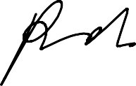
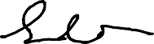
Sincerely,
Bob Hamiton, Director Tim Horton, Director

